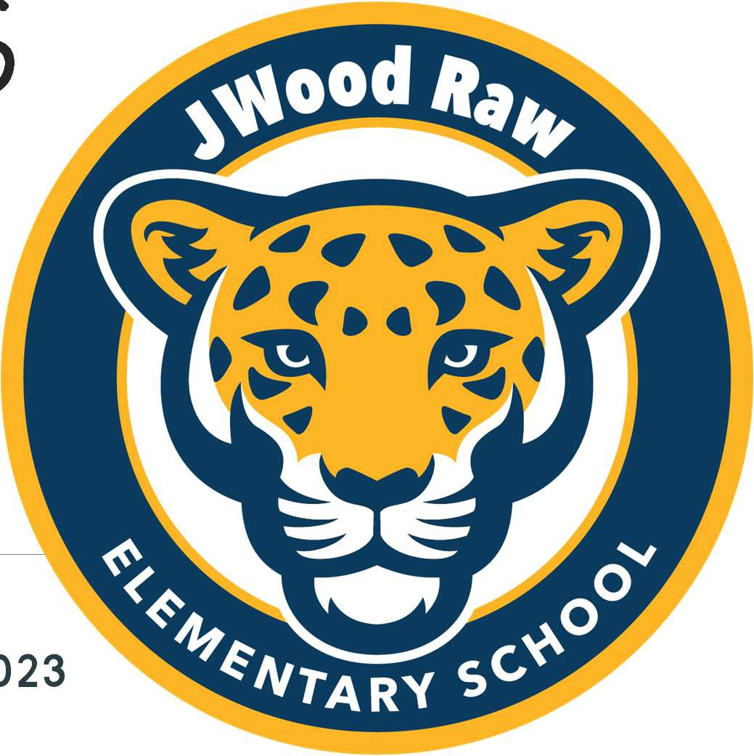**JWood Raw ES Kindergarten** 2023-2024

SCREENING WEEK: AUGUST 14-18

FIRST DAY OF SCHOOL: AUGUST 21, 2023

Principal:

Jonna AuCoin

Dean of Students:

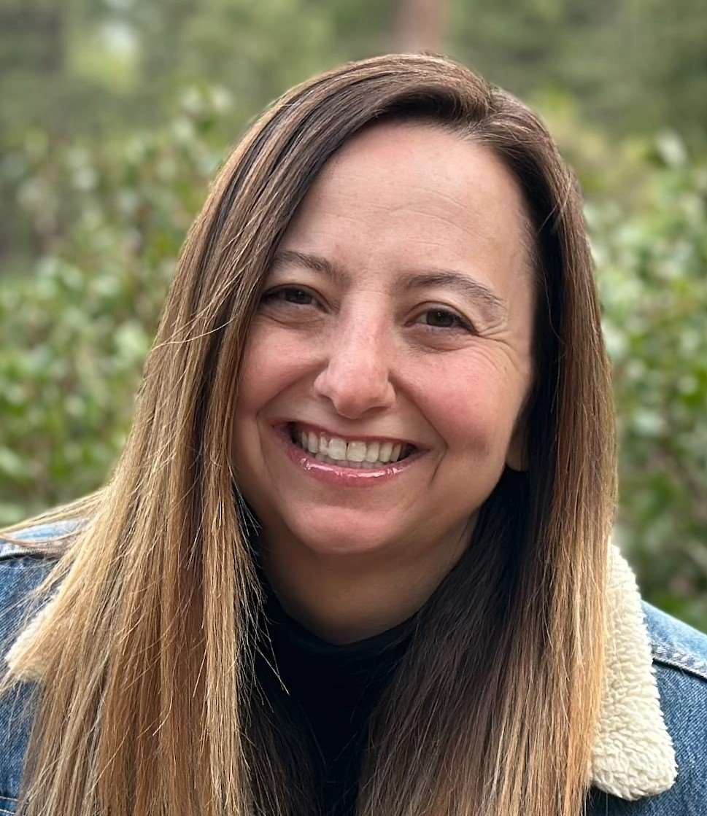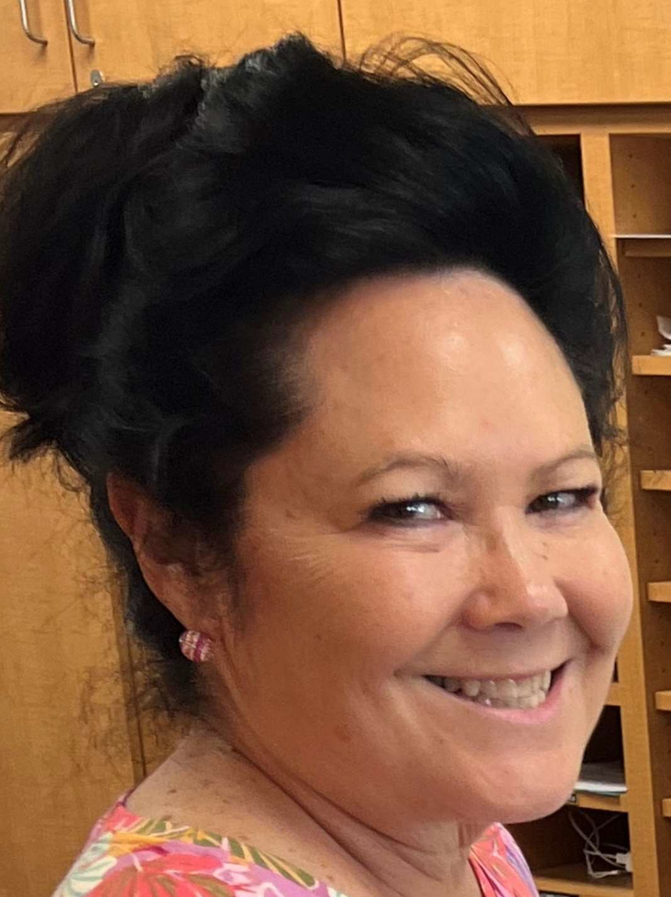

Kristy Pearson

Kayleigh Smith

Counselor:

Courtney Lee

Kendall Sugimoto

Administrative Secretary:

Cindy Cook

Music:

Sarah Vollenhals

# Meet our Team!

Teachers:



Holly Bliss



* To explain Teacher and Student Expectations

Goals for today:

* To share important information about Jwood Raw Elementary School
* TO provide ways you can support your Kindergartener at home
* To answer any questions you may have!

Pick-Up Routines:

Walkers Car Riders Bus Riders

Afterschool Care

Specials: Music Library

Tech Lab

Sample Schedule

Morning Bell: 8:55am

Afternoon Dismissal: 3:00, 2:15 Wednesdays



Time Activity

8:55 Doors Open, Morning Work

9:15

Morning Message

9:25

Daily Phonics Practice

9:35

ELA/Reading

10:45

Recess/Snack

11:00

Reading Interventions/Literacy Centers

12:00

Lunch/Recess

12:45

Writing

1:00

Math Talks/Number Corner/Calendar

1:15

Math Lesson

1:35

Math Centers/Math Intervention

2:00

Special (Library, Music)

2:45

Clean-Up, Pack-Up

3:00

Dismissal



Snacks

Snacks and Lunches

Lunches

* Daily snack in the morning outside, before recess.
* Students bring own snack.
* Choose items that will fuel them for the day and help make it to lunch!

*TIP: Talk with your Kinder about choosing the best snack for the morning time if choosing from lunch box, or set aside*

* Cold Lunch vs. Hot Lunch
* School Provided Lunch (Free?)

Allergies

*igwr****l****iyPrnsothbsieaeue e ra eetheof cebeforetheschoolyear!*



We will have one designated class as Nut Free and will notify families at the start of the year of snack/lunch suggestions.

TIP: Talk with your kinder about being mindful of keeping food off of others (no sharing allowed) and being aware of others with allergies when eating with them.

# Parties and Birthdays



Class Parties

* + Occasional Class Parties during the year.
  + Communicated by teacher for theme and any edible donations needed.

*Always following with student allergies*

Birthdays

* No edible items to share with the class.
* Ideas:
  + - Goody Bags to send home
  + -Class set of mini Play-Doh
  + - Class set of outside chalk
  + Bring a favorite book to share with the class



District Policy:

Designated Treat Days—Students bring OWN (will be communicated by teachers) No Candy, Cakes, etc. to be shared with the class.

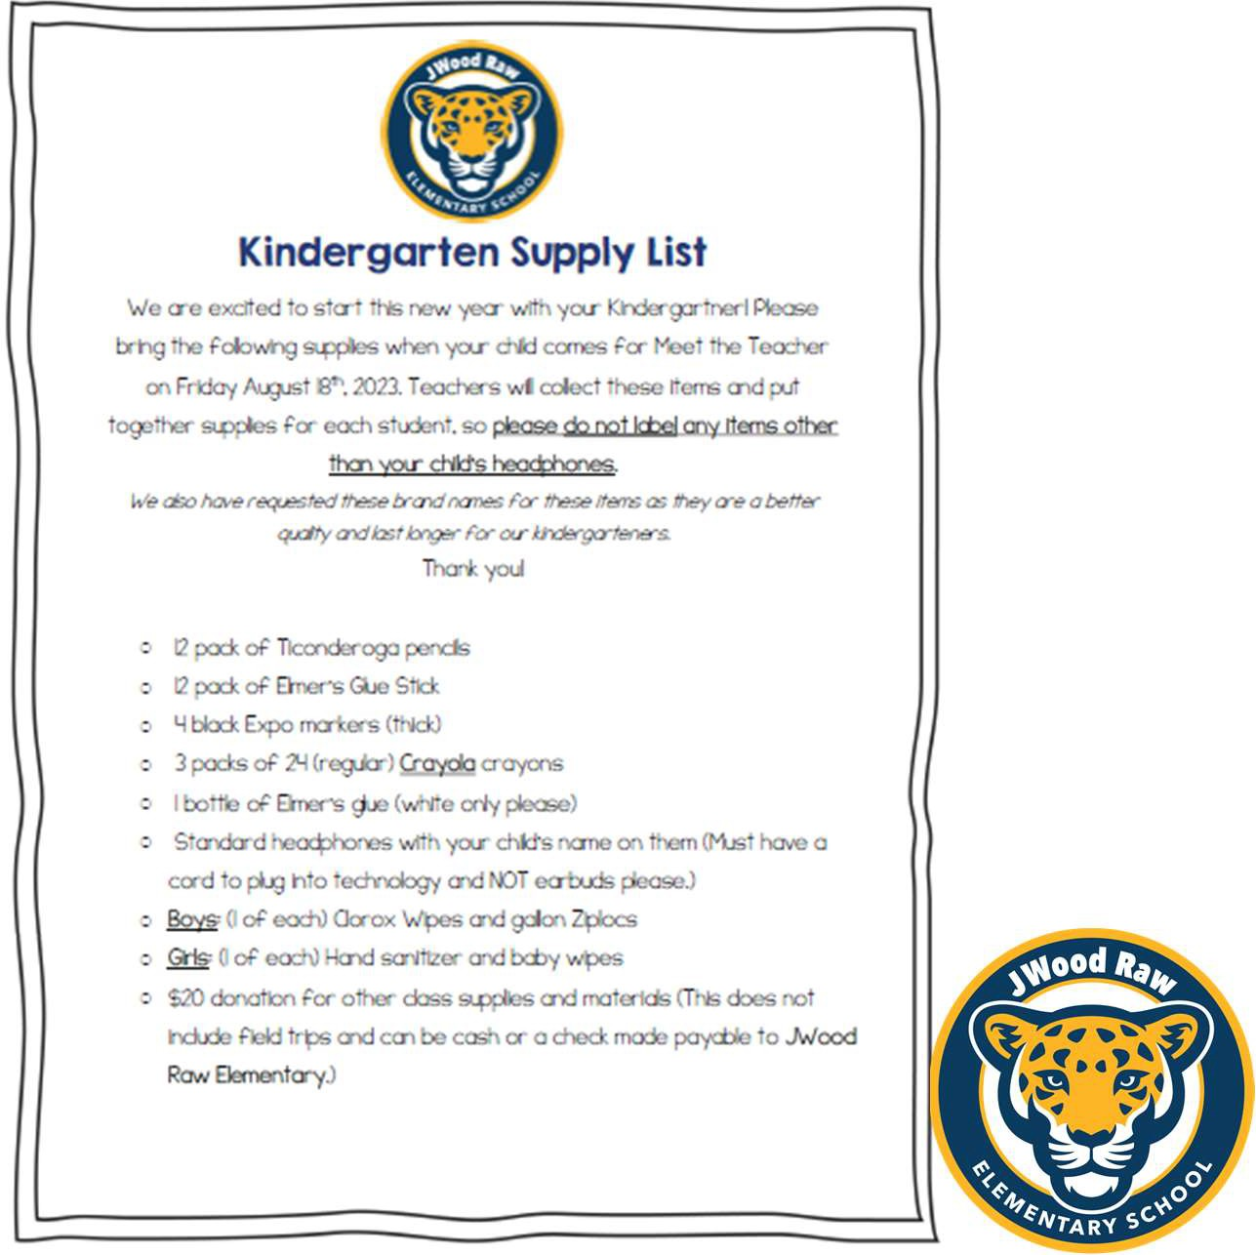

Student Supplies

Daily:

* Water Bottle
* Lunchbox/Snack

Fridays ONLY:

* Backpacks
* Folders (School will provide!)

EVERYTHING LABELED!

# Screening Week

August 14-16th

* + - Schedule an appointment when registering
    - Bring Student Supplies (if possible!)

At the appointment:

* Parent(s): Filling out surveys
* Kinder Student: Assessment with Teacher

*crowgt****l****Sripemltritbwayporsaotustgdn*

*eha e*

*g ithoutParentforthe*

*Assessment!*



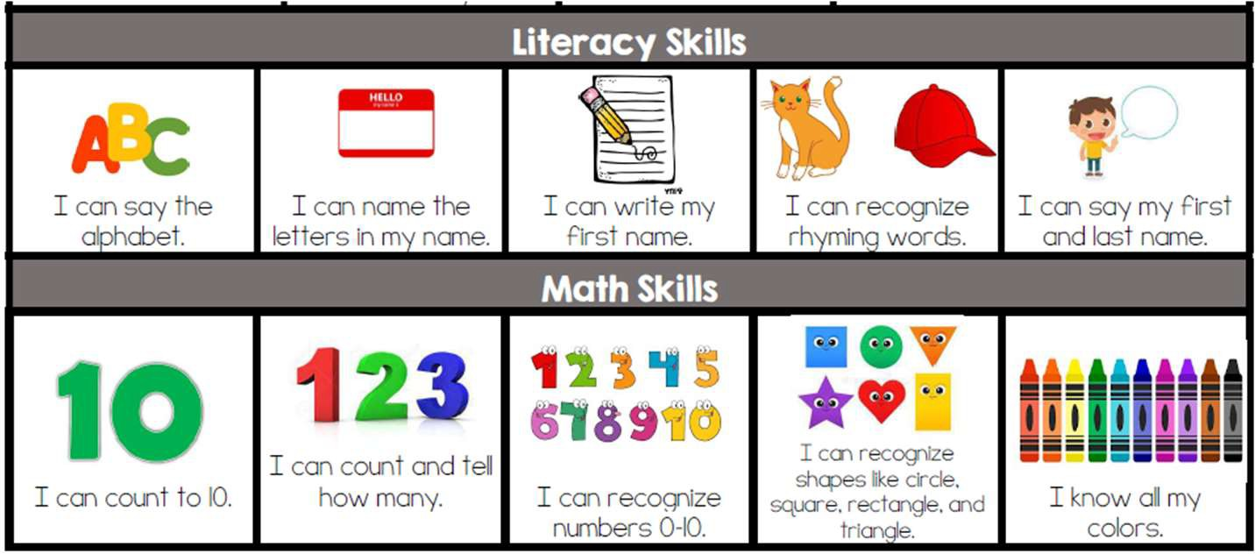

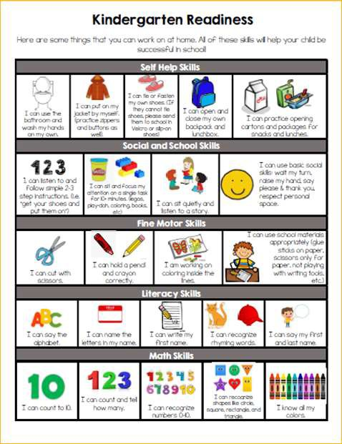

Kindergarten Readiness Skills

Academic Skills

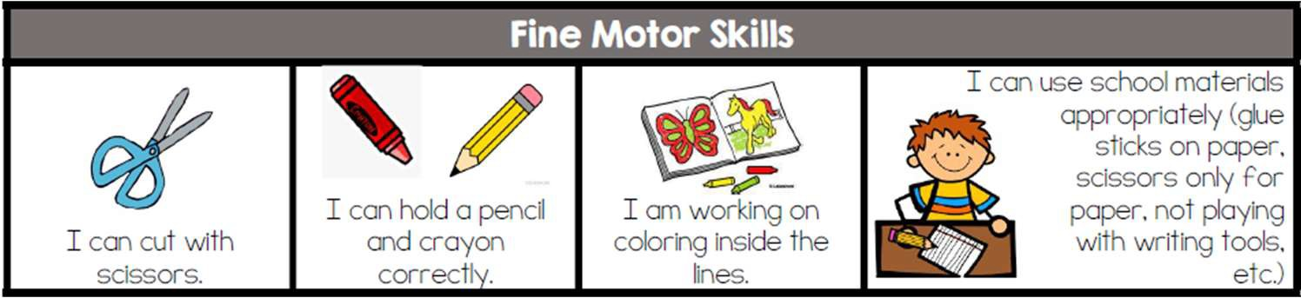

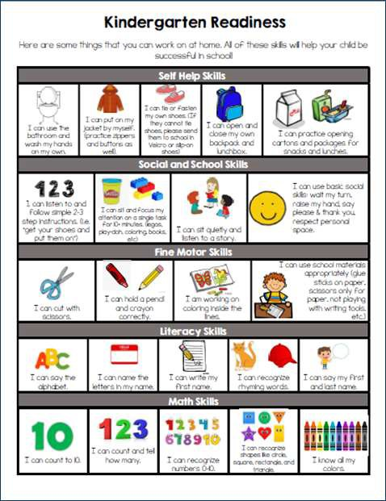

Kindergarten Readiness Skills

Fine Motor Skills

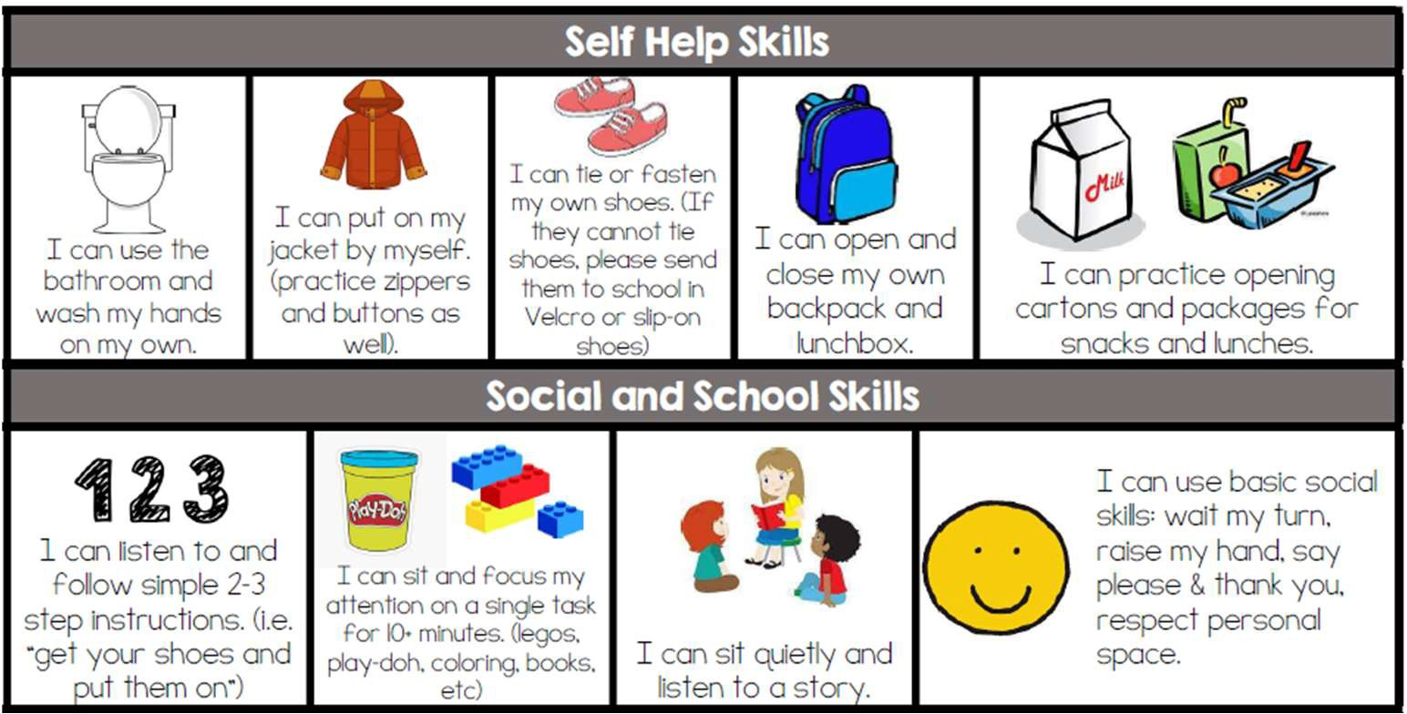

Routines at home to set up for school (checking backpacks, designated space to keep things, packing lunches/snacks/waters, wake-up time and getting ready routines)



Kindergarten Readiness Skills

Self-Help and School Skills

# Volunteering and PTO

We love volunteers!

We will have many volunteer opportunities within the school and classrooms. More details to come at the start of the year.



[insert QR COde]

To Volunteer:

Must fill our Volunteer Form and submit copy of Drivers License with the office.

Join the PTO!

# Enrichment and Technology

Aviation Focus

We will be partnering with Pathway to Aviation and Great Basin Aviation to support student enrichment opportunities.

Technology

* We will be TECH RICH, meaning 80% of technology in each classroom.
* K-2 Classrooms: iPads



* 3-5 Classrooms: Chromebooks

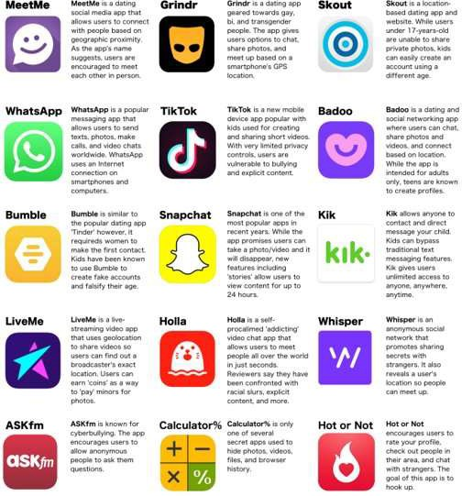 

Apps to know about

TikTok

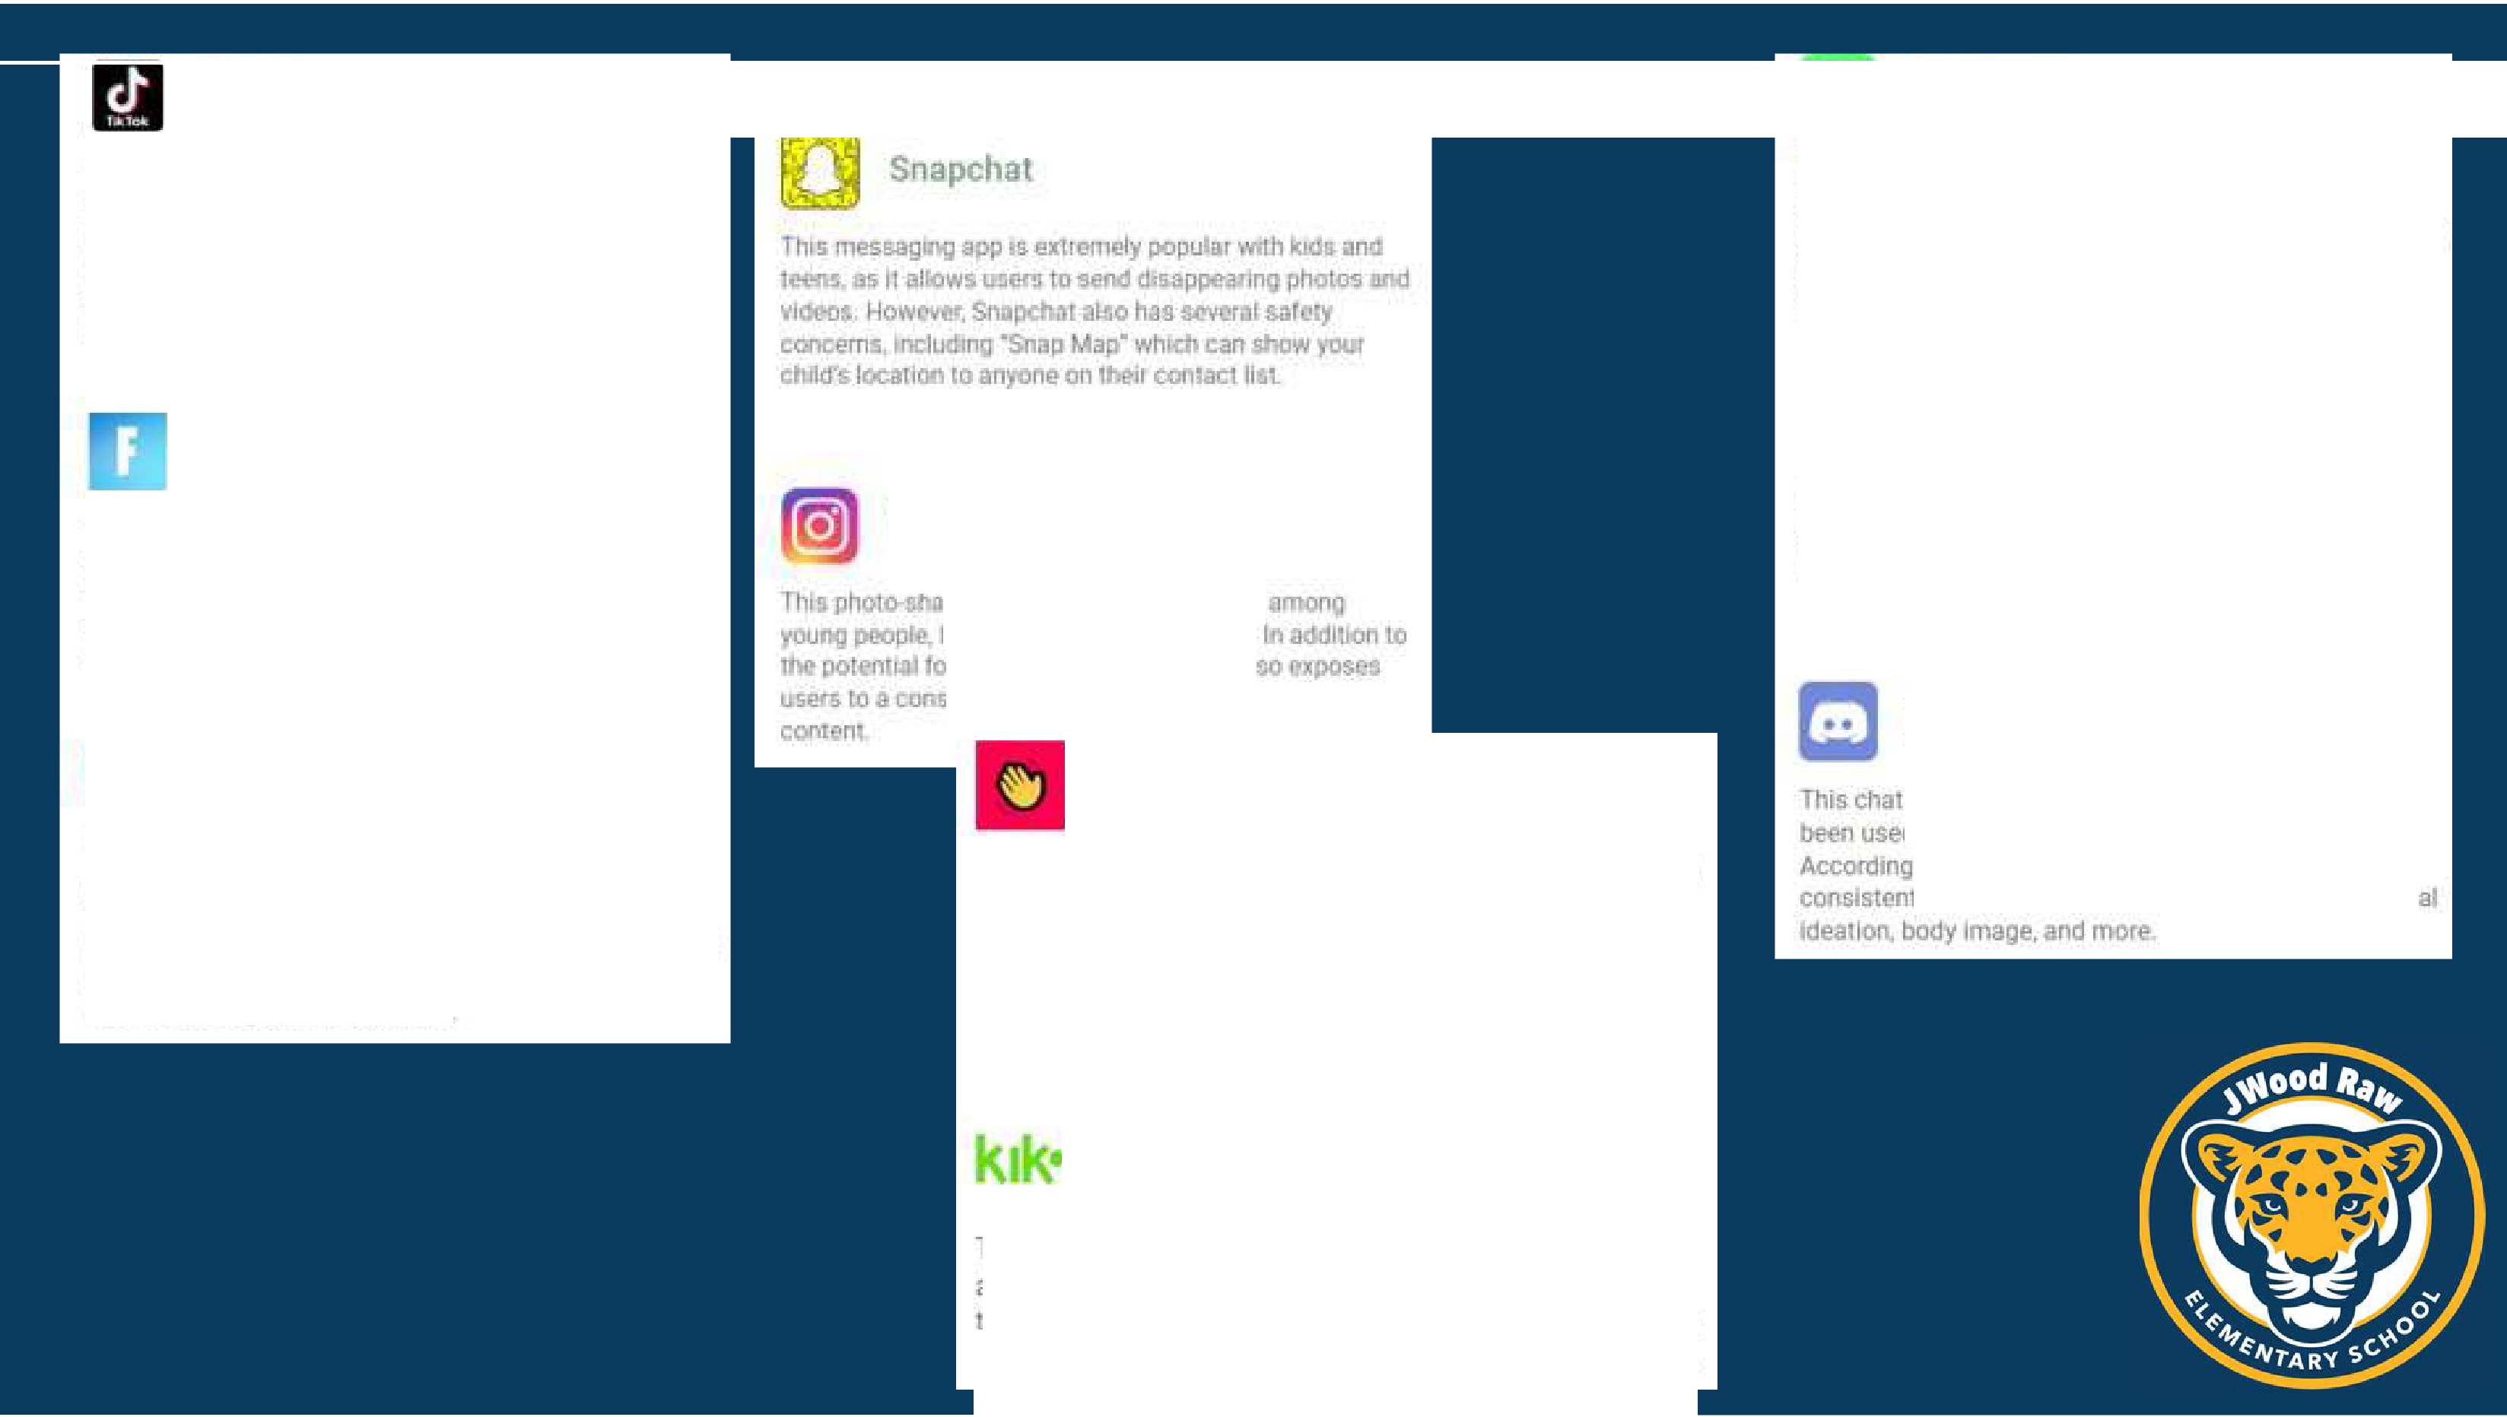

n11s popular vldeo-sha ring app allows users to aeale and shal't! short Yldf!o.s or hemserves LJp-svnc:.lng, rumctng *01* performing other crea1jve acts While **Tik** Tok can be a lot or tu for kid• tht>re ha e **b** 1m concetn!I aoout its sarety. as the app *has* been known t.o host lnappropr}ale and e11eo pornogrsph1e content

This m ssag1ng app is extremely popu r amon Ids:

,mo teens. but 11 has ii numt>er cf Mlety com:-erns. rn

addlt on 10 the potenUal for c betooll lng, W alsAJ)p also airaw users[ sharett,elr loca ion 11h 01 ers, Jilch can be dangerous

For1ni'te

This online mu!llpla.yer game has taken 11 world by storm, with jds a11d adults all e spending hours upon hours playin!'.I While for111ite am be a f1.10 and h:nmless **game, 1herQ** have been concerns aboul its v1olem:e and addlt:11ve nature

I# YouTube

Thrs video-sharing platl□rm Is one or the most popular webr.1res in the world, w1ch oillions or users WhilL?

YouTube can be a great resource 1or educallcnal arid flt!'!rtalnlng colllenl, ll's Important to monnnr your chlJd's ac1l1,111y on lhe SI *e,*as **ltlere Is** lot of 1nappropr1a1e **and**

!!Yl!n dislurb111g co1uen1 avaiJab!ll.

lnstagrami

n DU nr

b ii OU&

r v1n mal

st.mt lte.lm ol BI1li anc:I :;.pooooted

Houseparty

Thjs video-chatting app 1s popular among klds and teens, but it has been known to allow strangers into chats whlcli can lead 10 inappropriate cornent betng shared.

**Kik**

This rnessaglng app js ex.tremely popular among klds and teens but it lrns several safe y concerns In addition o he **potential** for cyberbull'(lng, Klk also **allows users to** share their location with others, wnlch can be dangerous

Hoop

1his□cia Imi.'dlil apµ is popull!r amorig kids ar1d toons but ll has been nown 10 allow str ngers inro chats. which can lead 10 lnappropr1 t C()nlenl bem shared

Di5cord

app ls popular emo11g gaml!lli, bu1 Jt has also d by predators **10** groom amf expfolt children

to Ba k's 2021 anr1ual rec,art round 01S<:ord

tly m Ille top fiv p s for bullying, ule:1d

# Tips for Parents

* Talk to your kids about the apps they’re using and why they like them.
* Set limits on how much time your kids can spend on their devices, apps, games, or specific websites
* Monitor your child’s activity on their devices, including their app usage and web browsing history.
* Be aware of the apps your kids are using and research their safety concerns. Block specific apps or limit time on them using Enhanced Parental control.
* Teach your kids about cyberbullying, online predators, and other dangers associated with the internet.

How to protect your child from dangerous apps

To make sure your child has access only to apps you approve of, we recommend three steps:

1. Evaluate your kid’s current phone apps.
2. Set up Ask to Buy (iPhones) or Purchase Approvals (Android).
3. Install a parental control app for app management, content filters, message monitoring, and much more.

Remember to explain what you’re doing and why. Without this guidance, your kids won’t know how to use apps safely once they’ve left the nest.



https://[www.safewise.com/dangerous-apps-for-kids/](http://www.safewise.com/dangerous-apps-for-kids/)

Important things to know about smartphone apps

Important things to know about smartphone apps

* + Apps can be renamed. If your kid knows they’ve downloaded an inappropriate app, they might try to hide it by renaming it and changing the icon through

the Shortcuts app on an iPhone. Once that’s done, they can remove the original icon from the home screen. The same thing can be done on an Android phone.

* + Apps can be hidden. Apps don’t have to show up on the home screen. Your kid can cover their tracks by setting up a harmless-looking shortcut, using the App



Library, or re-downloading the app on the App Store.

Huggy Wuggy sounds like a cuddly teddy bear. But the monster is actually an evil villain in the 2021 horror PC game Poppy Playtime by MOB Games. The blue stuffed bear is no Care Bear. When he opens his mouth, he has rows of sharp teeth. And that's just the tip of the

Common Games Played

iceberg.

Poppy Playtime is a game of survival set in an abandoned toy factory. Players must solve puzzles while Huggy Wuggy hunts them. He has inspired multiple YouTubers to create parodies of creepy songs, that, while not intended for children, are easy for kids to find and watch online.

Kissy Missy- is part of huggy wuggy, but she kisses you until you die then eats you.

Squid games- red light green light.



# Safe and Fun Apps







Thank you!

